• Are the HTML tags and elements the same thing?

**Ans**: No, they are not the same things.

Tags- Building blocks of HTML page.

Ex: <h1></h1>

Elements- Components that are used in HTML page.

Ex: <h1>Hello</h1>

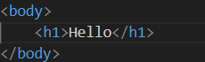

**Output:**

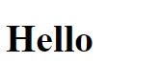

• What are tags and attributes in HTML?

**Ans:**  Both the tags and attributes are within the elements.

Ex: style, class, id.

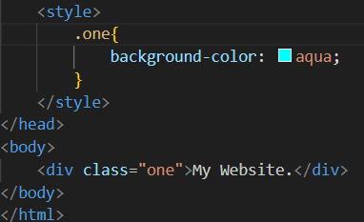

**Output:**

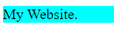

• What are void elements in HTML?

**Ans:** Void elements is an element whose content model never allows it to have contents under any circumstances.

Ex: br, hr, img.

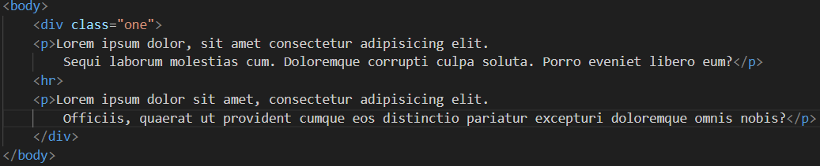

**Output:**

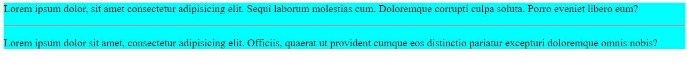

• What are HTML Entities?

**Ans:** Entities are frequently used to display reserved characters and invisible characters.

Ex: &nbsp, &copy, &pound.

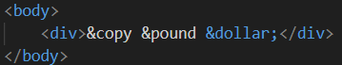

**Output:**

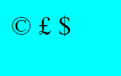

• What are different types of lists in HTML?

**Ans:** There are 3 types of lists in HTML that is,

1. Unordered list (ul)
2. Ordered list (ol)
3. Definition list (dl)

Ex:

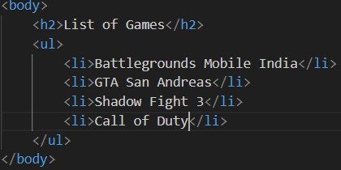

**Output:**

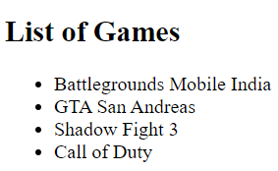

• What is the ‘class’ attribute in HTML?

**Ans:** The class attributes specify one or more class name for an element.

Ex:

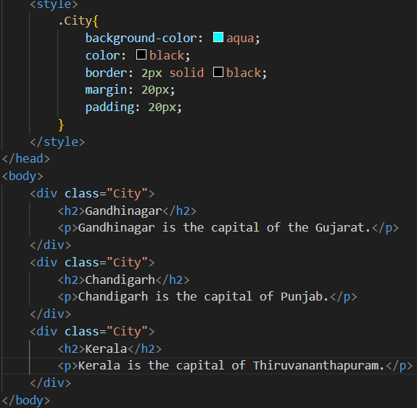

**Output:**

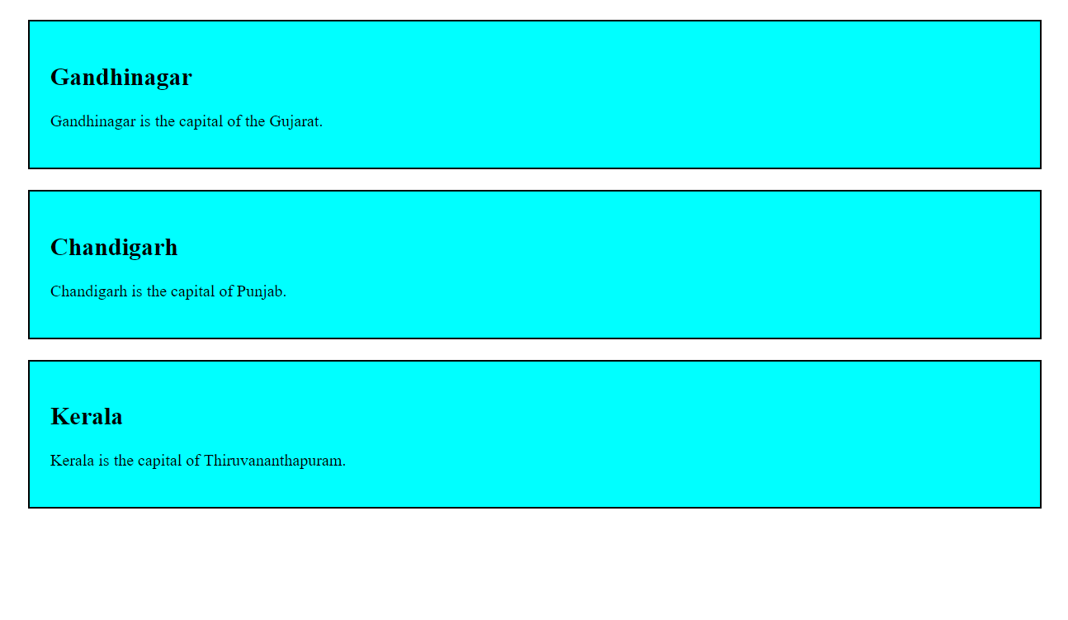

• What is the difference between the ‘id’ attribute and the ‘class’ attribute of HTML elements?

**Ans:** A class name can be used by multiple HTML elements and Id name must only be used by one HTML elements.

Ex:

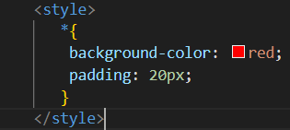

**Output:**



• What are the various formatting tags in HTML?

**Ans:** Formatting elements include the <b>, <i>, <u>, <strong> and etc.

• How is Cell Padding different from Cell Spacing?

**Ans:** Cell Padding is basically space present between a table cells border whereas Cell Spacing is present between individual cells of table.

Ex:

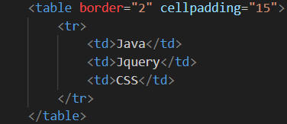

**Output:**

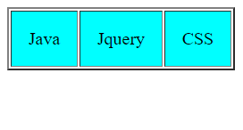

• How can we club two or more rows or columns into a single row or column in an HTML table?

**Ans:** It can be done by using the rowspan and colspan attributes in HTML.

Ex:

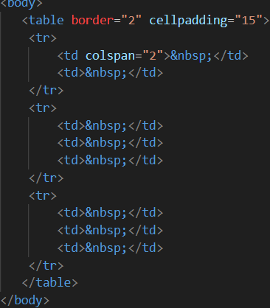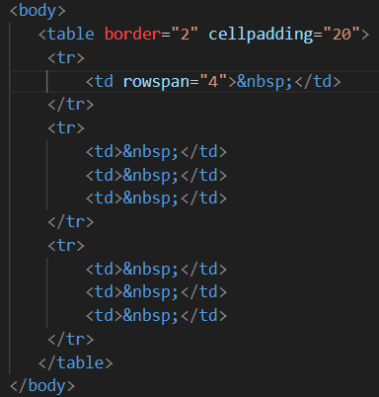

**Output:**

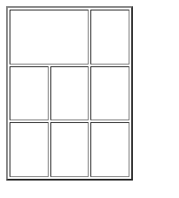 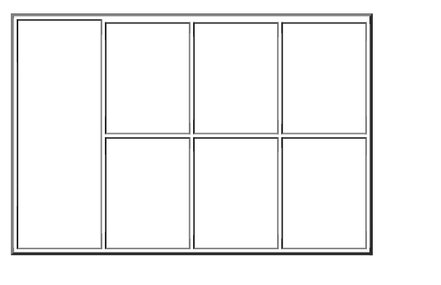

• What is the difference between a block-level element and an inline element?

**Ans:** Block-level elements only appear inside the body tag.

i.e.: <h1>, <div>, <p>.

Inline elements never start from new line.

i.e.: <bold>-<strong>, <i>-<em>,<del>-<strike>,<u>-<ins>.

• How to create a Hyperlink in HTML?

**Ans:** By using this tag <a href=”(internet URL)”.></a> we can create a hyperlink in HTML.s

• What is the use of an iframe tag?

**Ans:** iframe is used to load content from another site within the page.

**Output:**

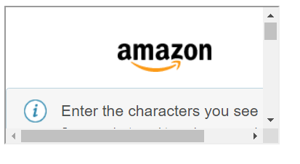

• What is the use of a span tag? Explain with example?

**Ans:** Span tag used to wrap section of text for styling purposes or to add attributes to a section of text without creating a new line of the content.

Ex:

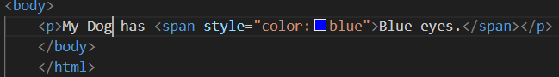

**Output:**

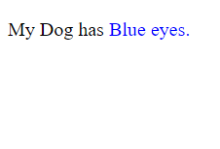

• How to insert a picture into a background image of a web page?

**Ans:** We can use the background attribute in the body tag to set an image as the background of the webpage.

Ex:



**Output:**



• How are active links different from normal links?

**Ans:** Active links are currently functional and lead to live webpages whereas Normal links can refer to any link whether functional or broken.

• What are the different tags to separate sections of text?

**Ans:** We can separate a section of texts by using the <br>, <p> and etc.

<br> tag is used to separate the line of text breaks the current line and shift the new line.

<p> tag is used to write a paragraph of text.

• What is SVG?

**Ans:** SVG is based on XML vector image format for defining two-dimensional graphics having support for interactivity and animation.

i.e.: .jpg, .png, .svg.

• What is difference between HTML and XHTML?

**Ans:** HTML is more lenient in its syntax, while XHTML has more strict syntax.

• What are logical and physical tags in HTML?

**Ans:** Physical tags are used to provide visibility appearance to text whereas Logical tags are used to add some logical or semantic value to the text.